Document Details

Document Type | User Manual -
Prepared by | Synthetic Gen -Product of Technopals UK Limited
Date | 03 Mar 2026

Table of Contents
1 INTRODUCTION 4
2 GETTING STARTED 5
3 DASHBOARD OVERVIEW 7
4 NATURAL LANGUAGE QUERY INTERFACE 9
5 POPULATION GENERATOR 10
6 ML TRAINING 12
7 MODEL MANAGEMENT 13
8 SYNTHETIC DATA GENERATION 15
9 DATA VISUALISATION 16
10 EV ADOPTION FORECAST 18
11 DISEASE SIMULATION 19
12 PROFILE MANAGEMENT 20
13 TERMS & CONDITIONS 21
14 TROUBLESHOOTING 21
15 SUPPORT & CONTACT 22
16 APPENDIX A: KEYBOARD SHORTCUTS 23
17 APPENDIX B: GLOSSARY 23

INTRODUCTION

What is SyntheticGen?
SyntheticGen is an AI-powered synthetic population intelligence platform designed to generate realistic, privacy-safe demographic and behavioural datasets for Greater London. The platform focuses on the following core capabilities:
- Synthetic Population Generation: Creating realistic virtual populations without privacy risks
- EV Adoption Forecasting: Predicting electric vehicle adoption patterns across London boroughs
- Health Risk Simulation: Modelling chronic disease incidence using demographic factors
- Natural Language Queries: Asking questions about synthetic data in plain English

Key Benefits
SyntheticGen is designed to serve a broad range of urban planning and public health professionals:
- GDPR Compliant – No personal data is stored or processed
- 6 Months Free Access – Full platform access for new users
- AI-Powered Analytics – Advanced machine learning models (CTGAN and TVAE)
- User-Friendly Interface – Intuitive dashboard design with natural language queries

System Requirements
To use SyntheticGen, ensure your system meets the following minimum requirements:
- Modern web browser: Chrome, Firefox, Safari, or Edge (latest versions)
- Stable internet connection
- Minimum screen resolution: 1280 x 720 pixels

GETTING STARTED

Creating an Account
To create your SyntheticGen account, follow these steps:
- Navigate to the SyntheticGen login page
- Click on the “Register” tab
- Fill in your details: Full Name, Email, and Password (minimum 8 characters)
- Read and accept the Terms of Service and Privacy Policy
- Click “Create Account”


Logging In
To access your account:
- Enter your registered email address
- Enter your password
- Click “Sign In


First-Time Setup
Upon your first login, you will be directed to the Dashboard. Take a moment to explore the navigation menu on the left sidebar, review your profile settings, and familiarise yourself with the available features.

DASHBOARD OVERVIEW
The Dashboard is your central hub for monitoring platform activity and accessing key metrics.
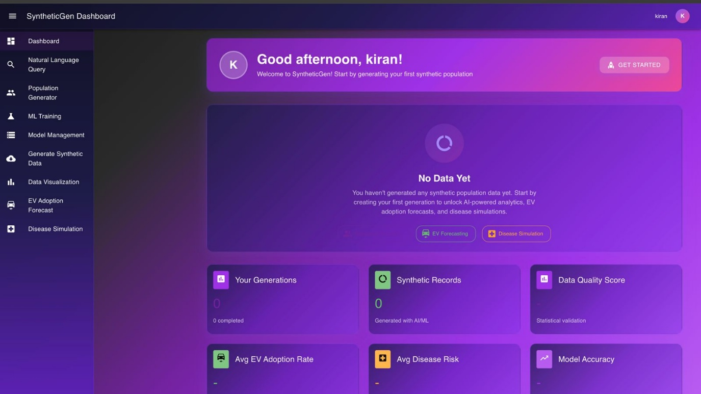

Key Statistics
The dashboard displays the following metrics at a glance:
Metric | Description
Total Generations | Number of synthetic populations you have created
Synthetic Records | Total number of synthetic individuals generated
EV Adoption Rate | Average electric vehicle adoption likelihood
Disease Risk Score | Average chronic disease risk across populations
Data Quality Score | Quality rating of generated data (0–100%)
Model Accuracy | Machine learning model performance

Quick Actions
From the dashboard, you can quickly view recent generation summaries, navigate to specific features, and access your profile settings.

Navigation Menu
The left sidebar provides access to all main features:
Menu Item | Function
Dashboard | Main overview page
Natural Language Query | Ask questions in plain English
Population Generator | Configure and create populations
ML Training | Train machine learning models
Model Management | View and manage trained models
Generate Synthetic Data | Create new synthetic datasets
Data Visualization | Charts and graphs
EV Adoption Forecast | Electric vehicle predictions
Disease Simulation | Health risk modelling

NATURAL LANGUAGE QUERY INTERFACE
The Natural Language Query Interface allows you to ask questions about your synthetic data in plain English, removing the need for complex database queries.
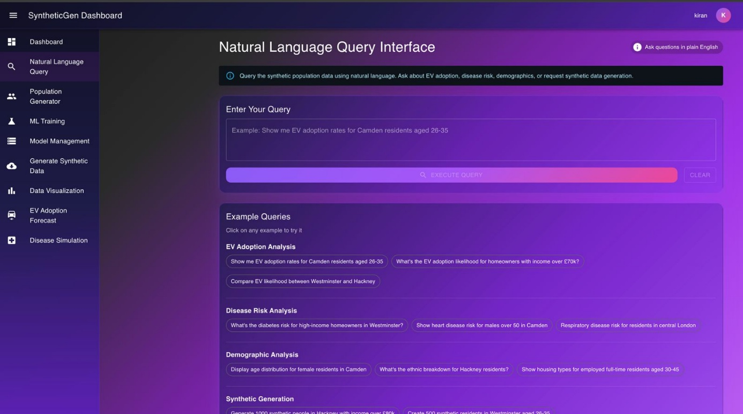

How to Use
From the dashboard, you can quickly view recent generation summaries, navigate to specific features, and access your profile settings.
- Navigate to Natural Language Query from the sidebar menu
- Type your question in the text box
- Click “Submit Query” or press Enter
- View results displayed below the query box

Example Queries
Query Type | Example
Demographics | Show me residents in Camden aged 25–35
EV Adoption | What is the EV adoption rate in Westminster?
Health Risk | Find high-risk diabetes individuals in Hackney
Statistics | Average income of homeowners in London
Comparisons | Compare EV adoption between Camden and Hackney

Query Results
Results are displayed with summary statistics, data tables, and export options (CSV, JSON). You can download the results for further analysis.

Tips for Better Queries
- Be specific about locations by using borough names
- Include age ranges when relevant to your query
- Specify the type of data you want (EV, health, demographics)
- Use comparative terms for comparisons between areas

POPULATION GENERATOR
The Population Generator allows you to configure and create new synthetic populations tailored to specific parameters.
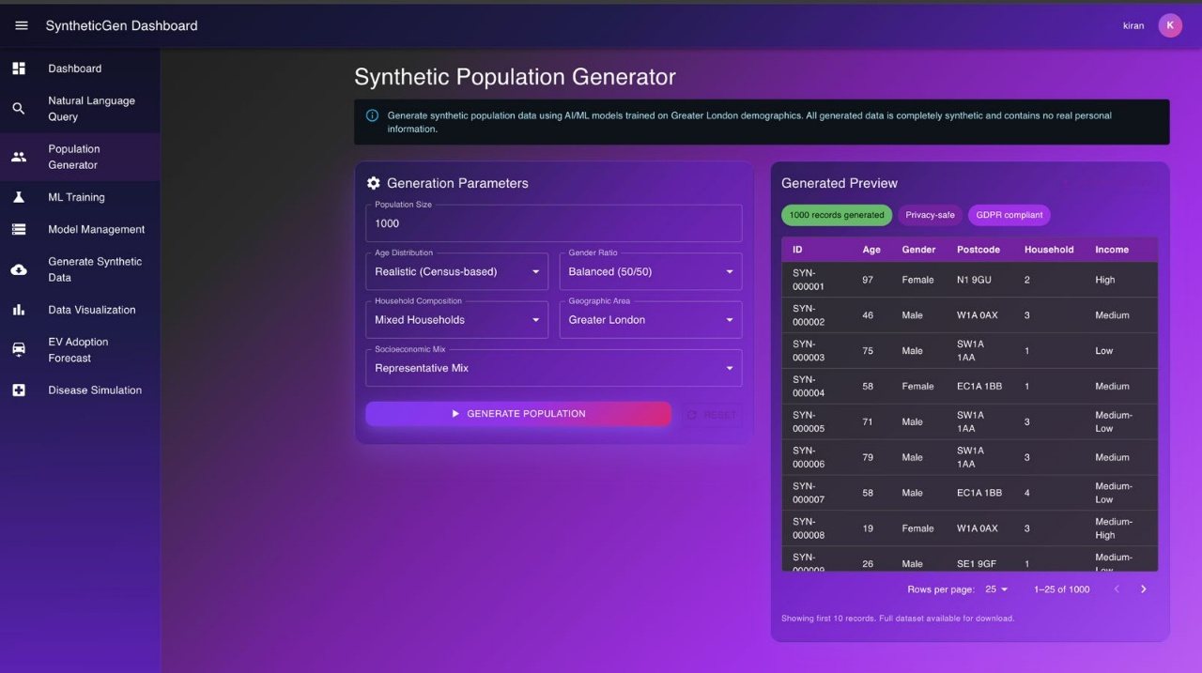

Configuration Options
Parameter | Description | Options
Population Size | Number of individuals to generate | 100 – 50,000
Target Borough | Geographic focus area | Camden, Westminster, Hackney
Generation Method | Algorithm type | CTGAN, TVAE, Hybrid

Steps to Generate
- Navigate to Population Generator from the sidebar
- Select your desired population size using the slider or input field
- Choose the target borough from the dropdown menu
- Select the generation method (CTGAN, TVAE, or Hybrid)
- Click “Generate Population” to begin

Monitoring Progress
During generation, the system displays a progress bar with percentage completion, estimated time remaining, and the current processing stage.

Viewing Results
Once generation is complete, you can view summary statistics, download the generated data in your preferred format, and proceed to analysis features such as Data Visualisation or EV Adoption Forecast.

ML TRAINING
Train custom machine learning models for improved synthetic data generation quality and accuracy.
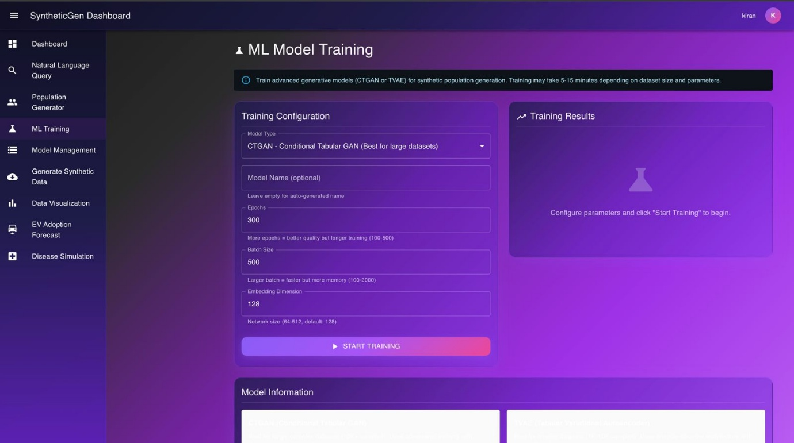

Available Models
Model | Description | Best For
CTGAN | Conditional Tabular GAN | Mixed data types
TVAE | Tabular Variational Autoencoder | Preserving rare patterns

Training Parameters
Parameter | Description | Default
Epochs | Training iterations | 300
Batch Size | Samples per batch | 1,000
Embedding Dimension | Feature representation size | 128

Starting Training
- Navigate to ML Training from the sidebar menu
- Select the model type (CTGAN or TVAE)
- Configure parameters or use the recommended defaults
- Click “Start Training” to begin the process

Training Progress
Monitor your training session with real-time loss metrics, a training epoch counter, and estimated completion time displayed on the interface.

MODEL MANAGEMENT
The Model Management section allows you to view, compare, and manage your trained machine learning models.
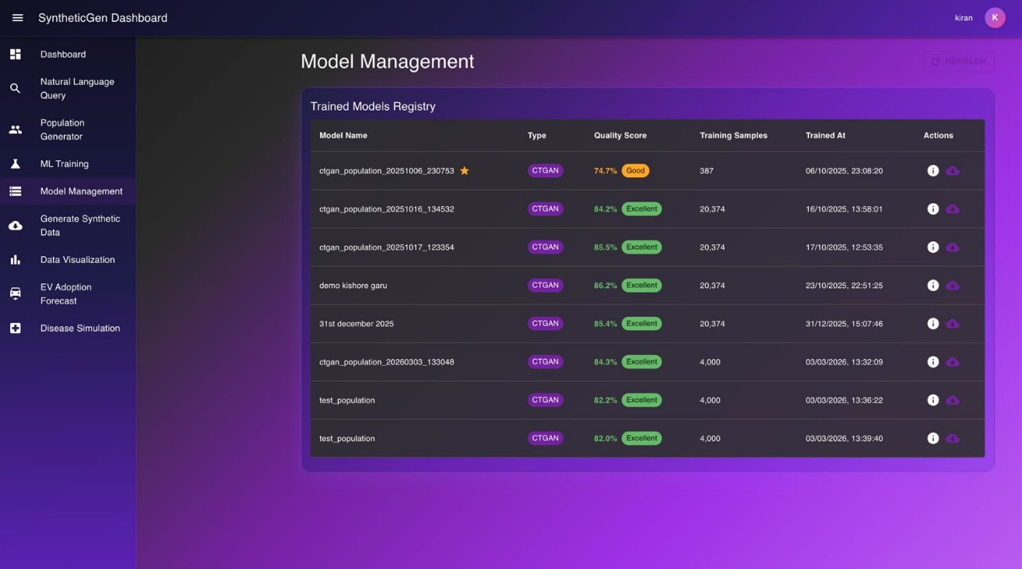

Model List
Each model entry displays the model name and type, training date, performance score, and status (Active or Archived).

Model Actions
Action | Description
View Details | See complete model information and training history
Set as Default | Use this model for future data generations
Download | Export model files for external use
Delete | Remove the model permanently from the platform

Performance Metrics
Model quality is measured by the following criteria:
- Distribution Matching – How closely synthetic data matches real-world patterns
- Correlation Preservation – Maintaining relationships between data attributes
- Privacy Score – Level of protection against re-identification of individuals

SYNTHETIC DATA GENERATION
Create new synthetic datasets using your trained models with full control over output configuration.
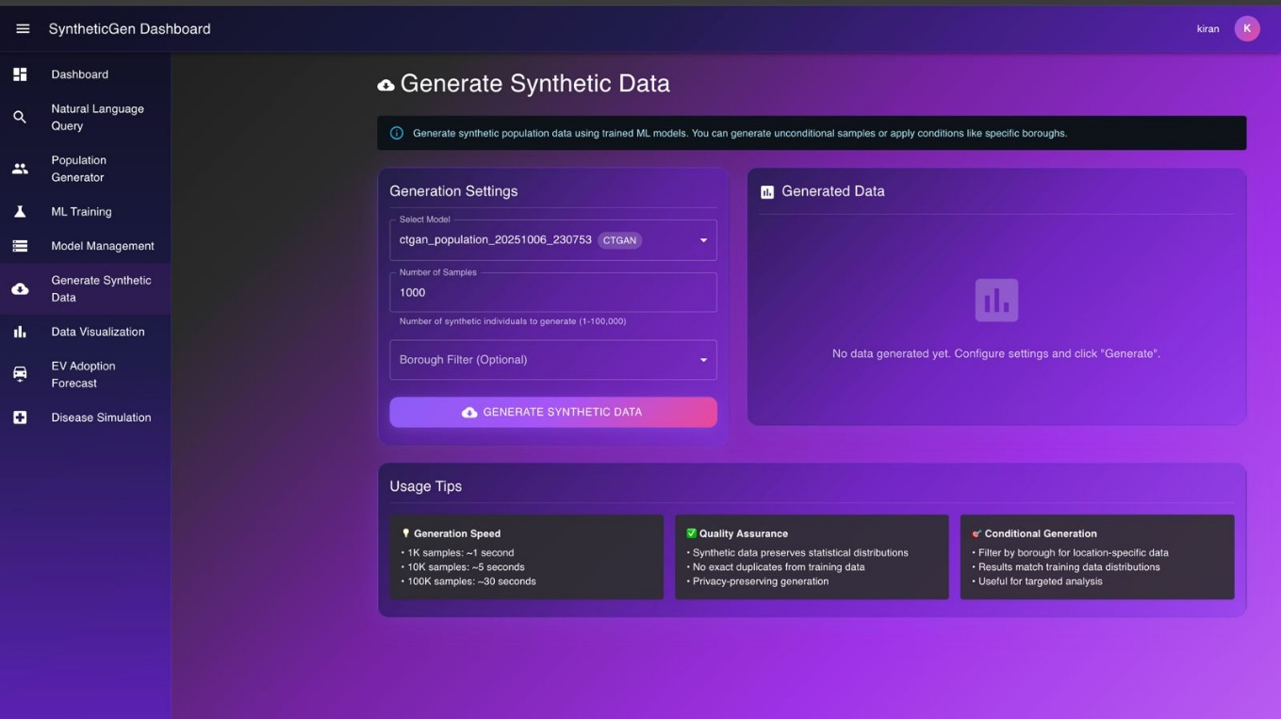

Generation Options
Option | Description
Model Selection | Choose which trained model to use
Output Size | Number of records to generate
Include Scores | Add EV adoption and health risk scores
Export Format | CSV, JSON, or both

Generation Process
- Navigate to Generate Synthetic Data from the sidebar
- Select your trained model from the dropdown
- Configure output options (size, scores, format)
- Click “Generate” to start the process
- Download results when the generation is complete

Output Fields
Generated datasets include fields across five categories:
Category | Fields
Demographics | Age, Gender, Ethnicity
Location | Borough, Ward, Postcode
Economic | Income, Employment Status, Housing
EV Adoption | Likelihood Score, Switch Year, Charging Preference
Health Risk | Diabetes Risk, Heart Disease Risk, Respiratory Risk

DATA VISUALISATION
Explore your synthetic data through interactive charts, graphs, and geographic maps.
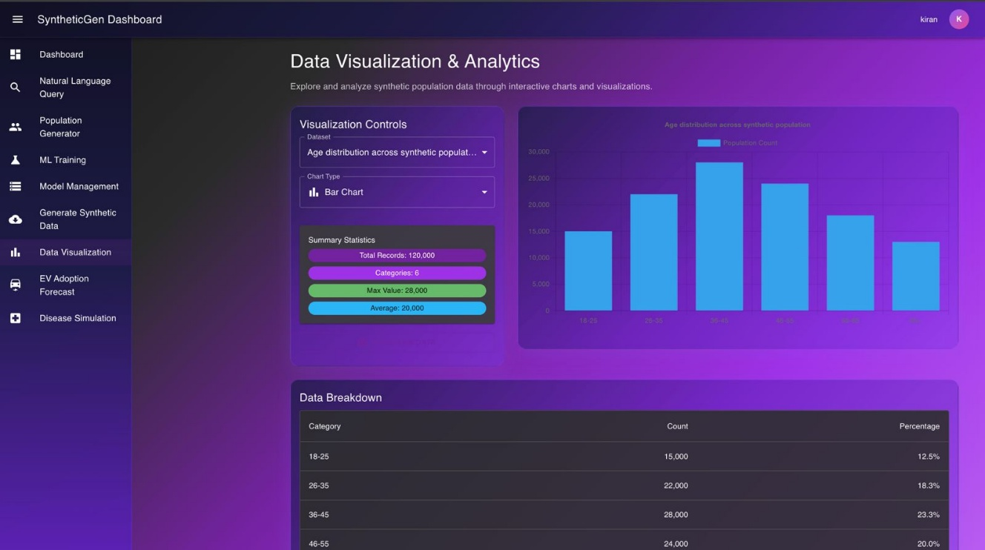

Available Charts
Chart Type | Description
Demographics Distribution | Age, gender, and ethnicity breakdown
Geographic Heat Map | Population density by area
Income Distribution | Economic status analysis
EV Adoption Trends | Adoption rates over time
Health Risk Matrix | Disease risk correlations

Interactive Features
- Hover over data points for detailed tooltips
- Click to filter by specific category
- Zoom in on specific areas of interest
- Export charts as image files for reports and presentations

Map View
The geographic map view displays population density by borough, EV charging station locations, and health service coverage across Greater London.

EV ADOPTION FORECAST
Analyse and predict electric vehicle adoption patterns across Greater London using advanced machine learning models.
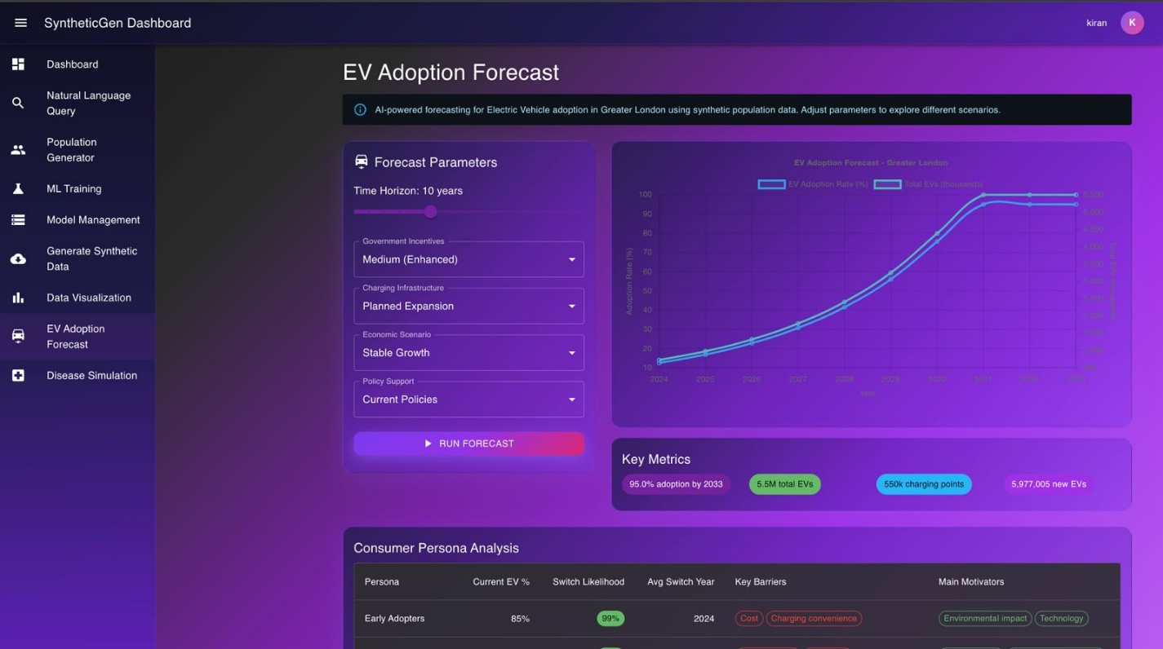

Key Metrics
Metric | Description
Adoption Likelihood | Probability of EV purchase (0–95%)
Predicted Switch Year | When individual may switch to EV (2024–2039)
Charging Preference | Home, workplace, or public charging
Current Vehicle Type | Existing vehicle category

Factors Influencing Adoption
The predictive model considers a range of demographic and economic factors:
- Housing type (homeowner versus renter)
- Income level and employment status
- Age and geographic location
- Current transport patterns and vehicle ownership

Forecast Reports
Generate comprehensive reports showing borough-level adoption rates, demographic breakdowns, infrastructure requirements, and timeline projections for planning and policy purposes.

DISEASE SIMULATION
Model chronic disease incidence and analyse risk factors across synthetic populations for public health planning.
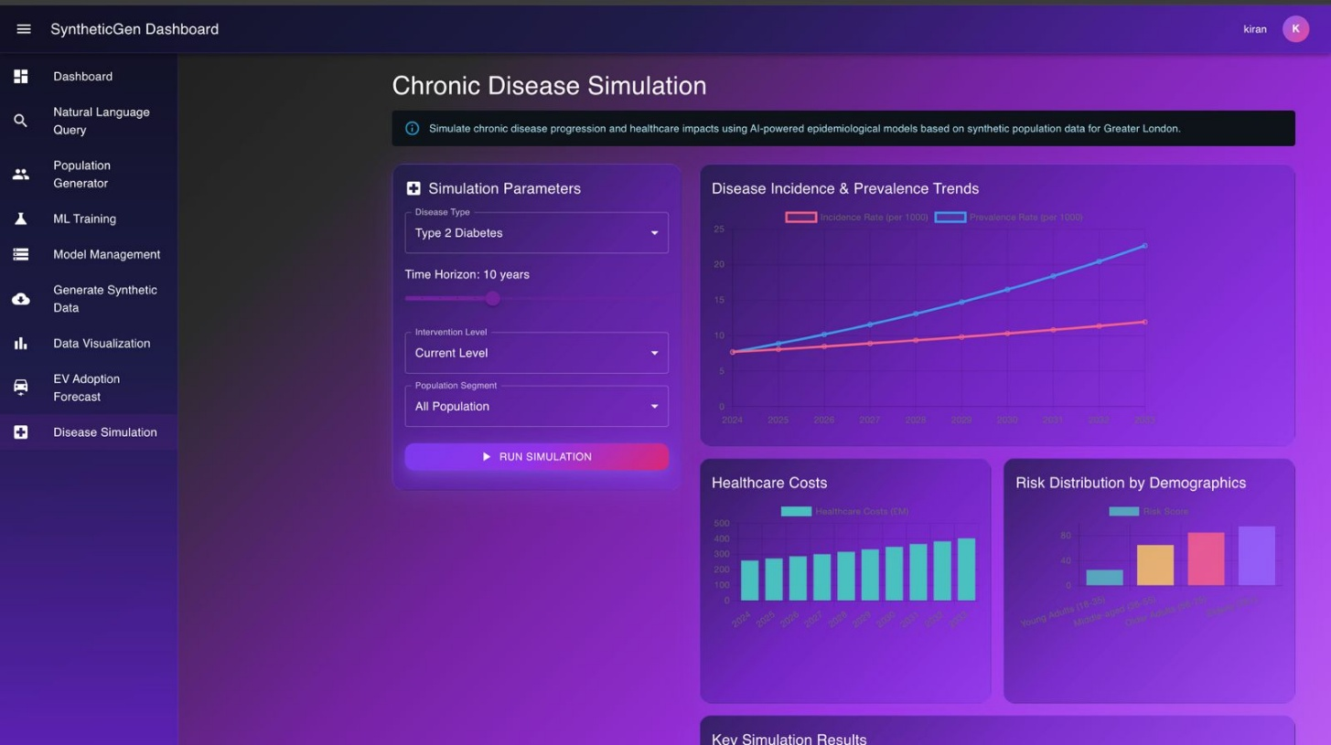

Supported Conditions
Condition | Risk Factors
Diabetes | Age, BMI proxy, income, ethnicity
Heart Disease | Age, gender, income, employment
Respiratory | Age, housing type, location

Risk Categories
Category | Score Range
Low Risk | 0–25%
Medium Risk | 26–50%
High Risk | 51–75%
Very High Risk | 76–100%

Simulation Features
- Filter populations by risk category
- Compare disease risk across boroughs
- Analyse demographic patterns and correlations
- Generate health impact reports for stakeholders

PROFILE MANAGEMENT
Manage your account settings, personal information, and subscription details.
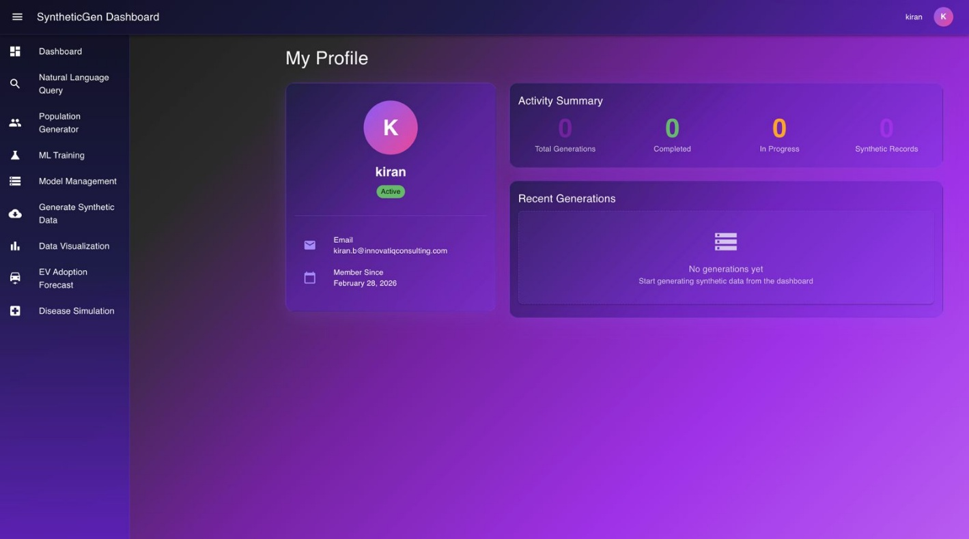

Profile Information
You can update your full name, email address, and password at any time through the profile settings page.

Account Details
View your account creation date, subscription status, free trial end date, and usage statistics from your profile.

Subscription Information
Your 6-month free trial includes full platform access, unlimited queries, model training capabilities, and data export features. No charges will apply during the trial period.

TERMS & CONDITIONS
Access the complete Terms and Conditions from the user menu (top right corner) or directly from your profile page. The Terms display your Effective Date based on your registration date.
Key Points
- 6 Months Free – No charges during the trial period
- GDPR Compliant – No personal data is processed or stored
- Data Ownership – You retain full rights to all generated data
- Support – Email support available within 24–48 business hours

TROUBLESHOOTING

Common Issues
Issue | Solution
Cannot log in | Reset password via the email link on the login page
Generation failed | Reduce population size and try again
Slow performance | Clear browser cache and refresh the page
Data not loading | Check your internet connection and retry
Export failed | Try exporting a smaller dataset

Error Messages
Error | Meaning | Action
Session expired | Login timeout occurred | Log in again
Rate limit exceeded | Too many requests sent | Wait 1 minute and retry
Generation error | Process failed unexpectedly | Retry with a smaller size
Model not found | Model deleted or unavailable | Select a different model

Browser Compatibility
For the best experience, use the latest version of Google Chrome, Mozilla Firefox, Microsoft Edge, or Safari.

SUPPORT & CONTACT

Getting Help
Email: enquiry@technopals.com
Response Time: Within 24–48 business hours

Company Information
Technopals UK Limited
Company No. 14907165
Office-9, 708A, High Road
North Finchley, London – N12 9QL
United Kingdom

Feedback
We welcome your feedback to improve SyntheticGen. Please email us with feature suggestions, bug reports, or general feedback.

APPENDIX A: KEYBOARD SHORTCUTS
Shortcut | Action
Ctrl + / | Open quick search
Esc | Close modal or dialog
Enter | Submit form

APPENDIX B: GLOSSARY
Term | Definition
CTGAN | Conditional Tabular Generative Adversarial Network
TVAE | Tabular Variational Autoencoder
Synthetic Data | Artificially generated data that mimics real-world patterns
EV | Electric Vehicle
Borough | Administrative division of London
GDPR | General Data Protection Regulation

